Open questions are in red

1. Introduction

Purpose
We want to have a software system that helps logisticians building tours. Tours consist of items that should be delivered to adresses. The truckers will see their tours on their mobile phones and will mark each item as delivered or not delivered. The system will also keep track of the time each tour has taken.

Stakeholders

Logisticians
What they do?
They prepare the tours for the truckers. They decide which truck is going to deliver which item. They give the Truckers a list with the items the truckers should deliver and with the address of the customers.
What do they expect from the system?
- They need to see on theiitems that have to be delivered in order to assign them to tours.
- They should be able to group items to tours with a few clicks.
- The software should be able to make suggestions about the tours. TBD: Ideas?
- They should be able to introduce to the system the amount of time that they expect that each tour should take. Is it really the time a tour will take? It is very unlikely that having twice the same tour.
- They should be able to compare the estimated time with the actual time.

Truckers
What they do?
They deliver the items to the customers. The items are already loaded on the trucks.
What do they expect from the system?
- They should see on the phone the tours for the next few days.
- They should be able to mark a delivery as sucessful or unsuccessful while on tour. This is done with the phone.

Senders/Recievers
Do we need interfaces for the people who send or recieve the objects?
Who creates a new item to be delivered? TBD. Do we need a list with items (i. e. Are we a webshop) or are we just a delivering company.
What happens if a item cannot be delivered several times?

Definitions
Item: One item is an object that should be delivered.
Tour: Several items together form a tour. A tour is executed by a trucker.

System overview

References

Overall description

Use cases

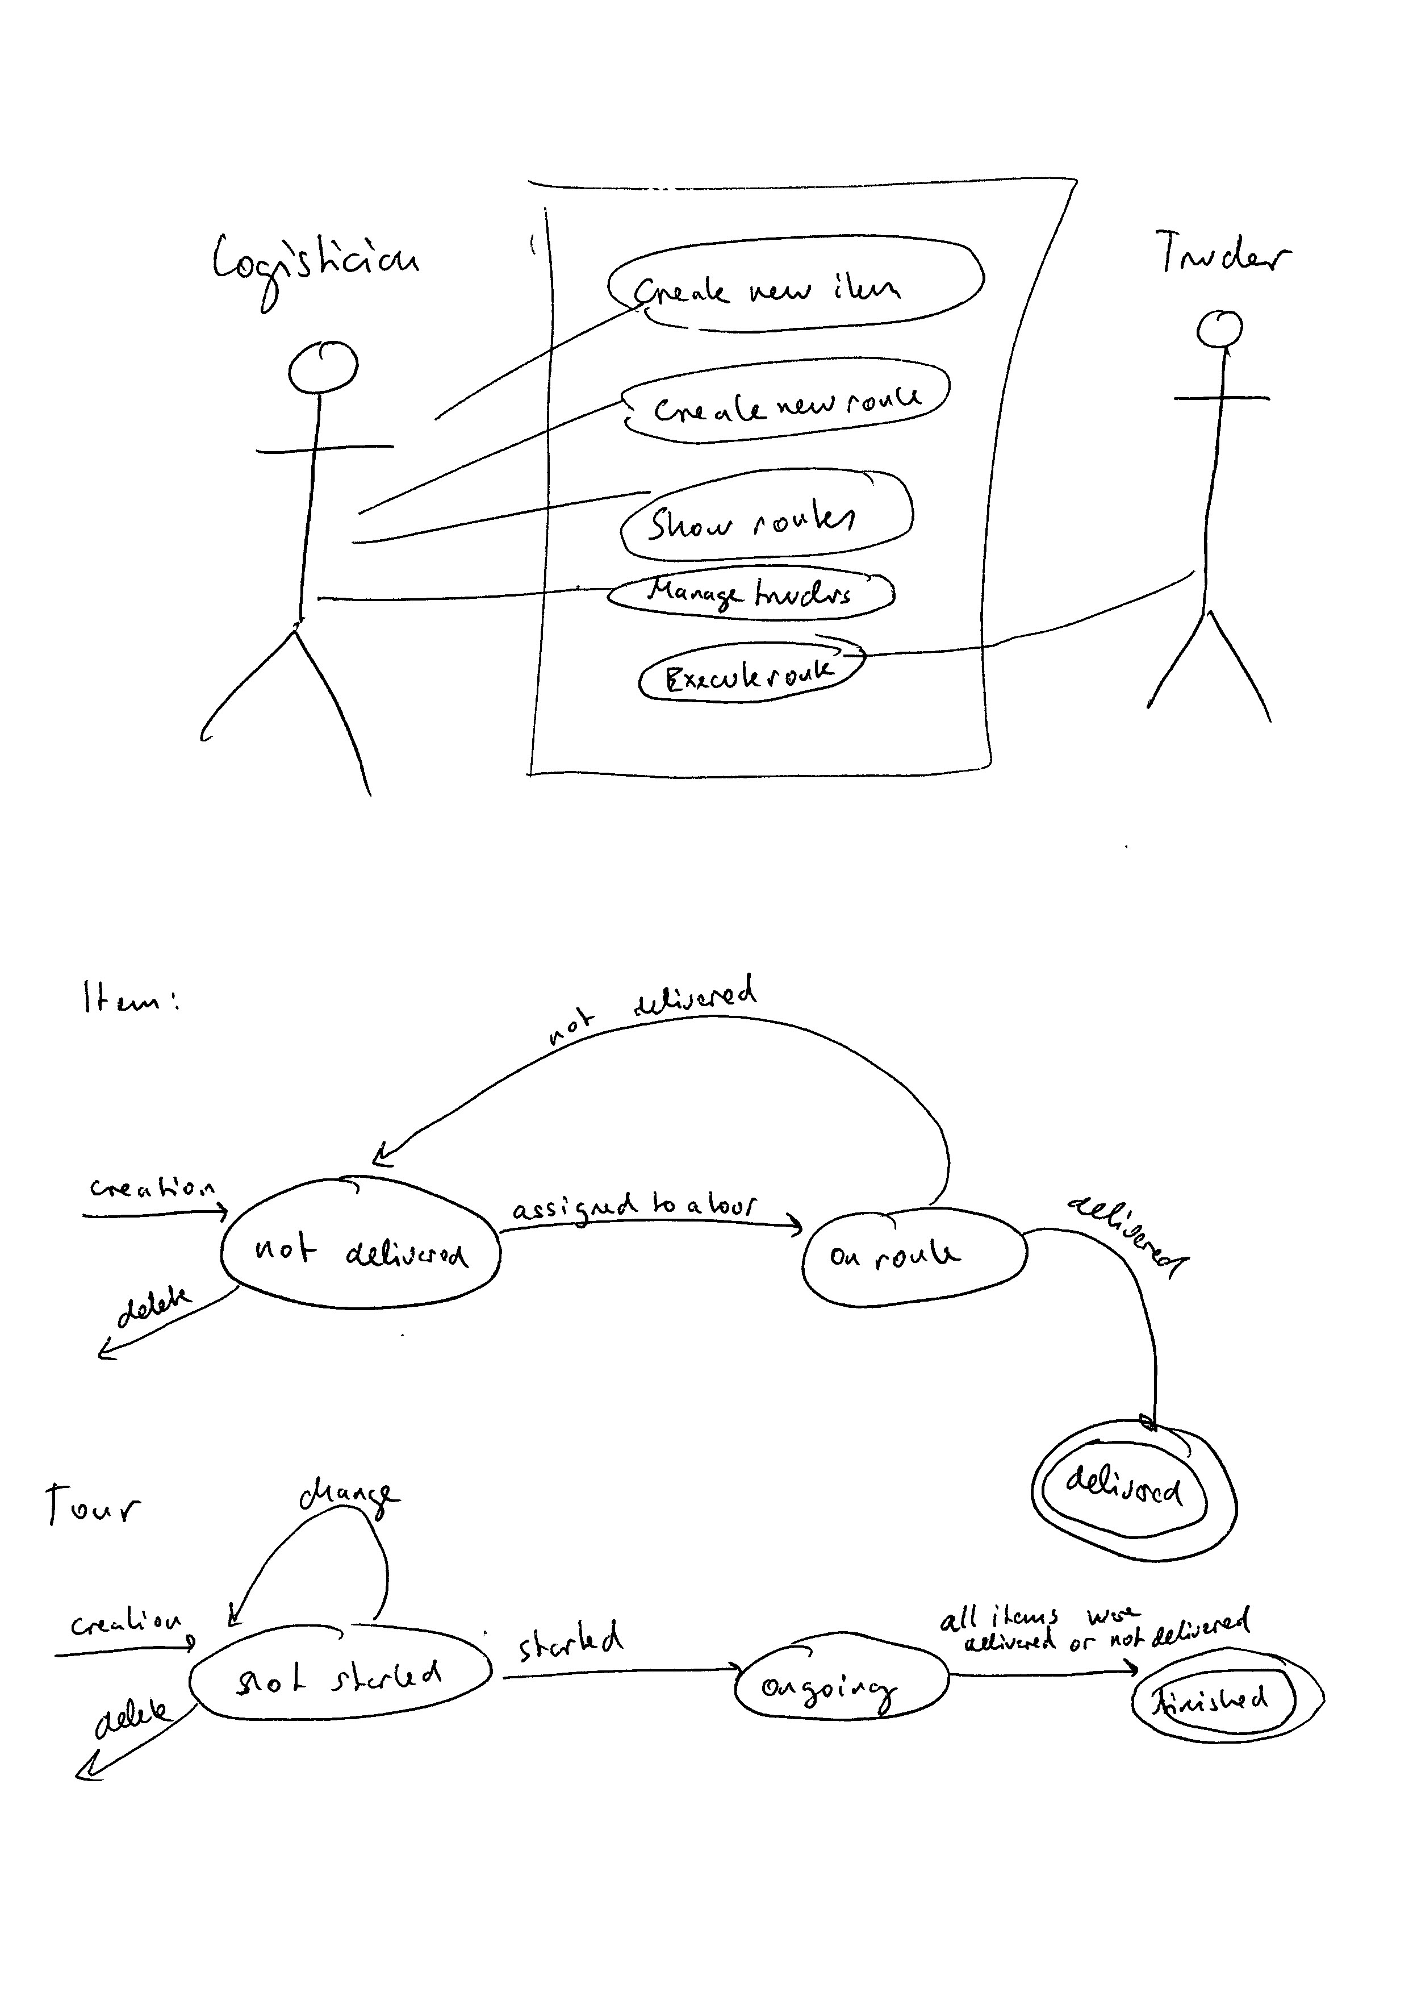

Actor characteristics
The logistician works on a desktop computer, he creates items, creates routes, can look at route statistics and can create and delete truckers.
The trucker can execute a route. This shows him a list with all the items that belong to the route. He then presses for each item on „delivered“ or on „not delivered“.

Specific requirements

Functional requirements
Items:
- The logisticians create items (Task: Create new item) which consist of a Name and a delivery address. After an item is created it belongs to the items that should be delivered (has status “not delivered”. Items can only be deleted if they were not delivered yet (if they have status “not delivered”).
- Items have the status „delivered“, „on route“, „not delivered“. After creation the have the status „not delivered“. Once they are assigned to a route they get the status „on route“. Depending on whether the trucker is able to deliver the change to „delivered“ or again to „not delivered“.
Trucker:
- A Trucker is created by the logistician (Task: Manage truckers) and only consists of a name. Truckers can be deleted, so that they do not longer show up in the route creation.
Creation and administration of Routes:
- A route is created by the logistician (Task: Create new route). The logistician first selects a Trucker from the trucker list and afterwards selects one or more items with the status „not delivered“. During the creation of a route he gives also an amount of time that he expects the route to take. The items which are assigned to a route get the status „on route“.
- Routes have three status: „not startet“, „ongoing“, „done“. Only routes with the status „not started“ can be deleted or manipulated. If a route is deleted all items in that route will change the status from „on route“ to „not delivered“.
- The logistician can access a list with all routes (Task: Show routes) where he sees the Trucker, the expected time and the effective time the route took. By clicking on a route he can see the items which are in the route. Only routes with the status „not startet“ can be deleted or manipulated.
Execution of routes:
- A tracker can select route (Task: Execute route) with the status „not startet“ and start the route. The starting time of the route is registered and the route gets the status „ongoing“.
- The trucker sees on the ongoing route all items that belong to that route and he can press „delivered“ or „not delivered“ for each item. Depending on his choice the status of the items change from „on route“ to delivered or to „not delivered“. In the „not delivered“ case the item shows up again when a logistician is going to create a new route.
- When all items on the route list have been either „delivered“ or „not delivered“ the trucker can press „route done“. This saves the current time (so that we can compute how long the route took). Moreover the route changes from „ongoing“ to „done“.

Tour generation: How should the software be able to propose tours?
What should the logistian be able to do with the information about the tour time?
What does it mean on the descritption: „so that we can investigate the odd ones out?“
Are there several logisticians? Should we implement Log-ins?
User interfaces:

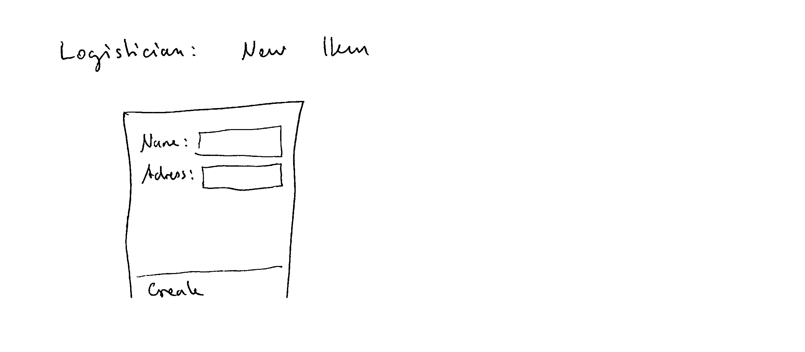
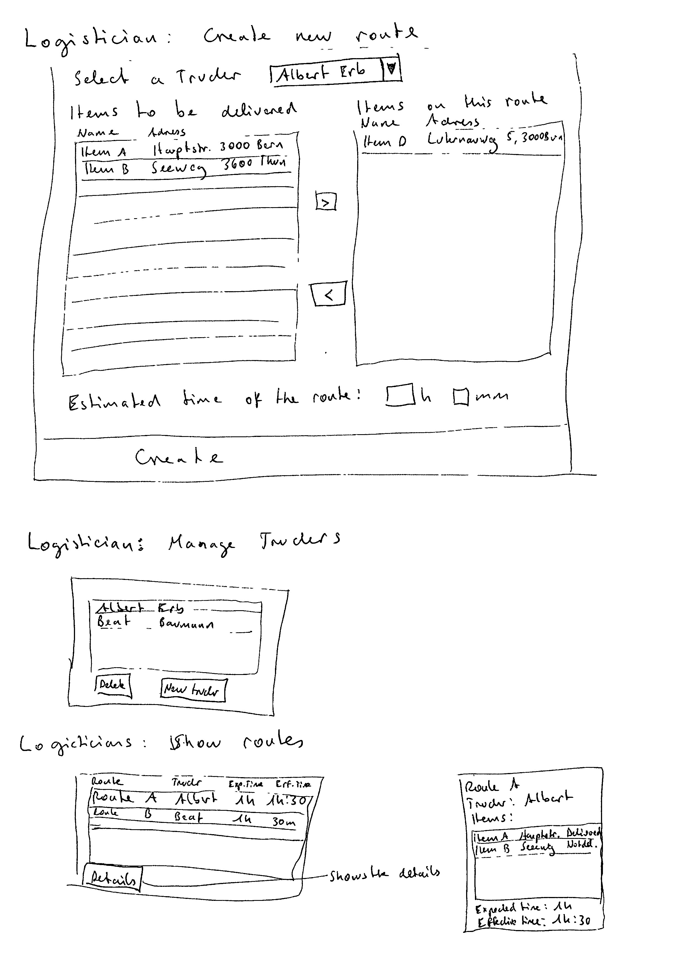
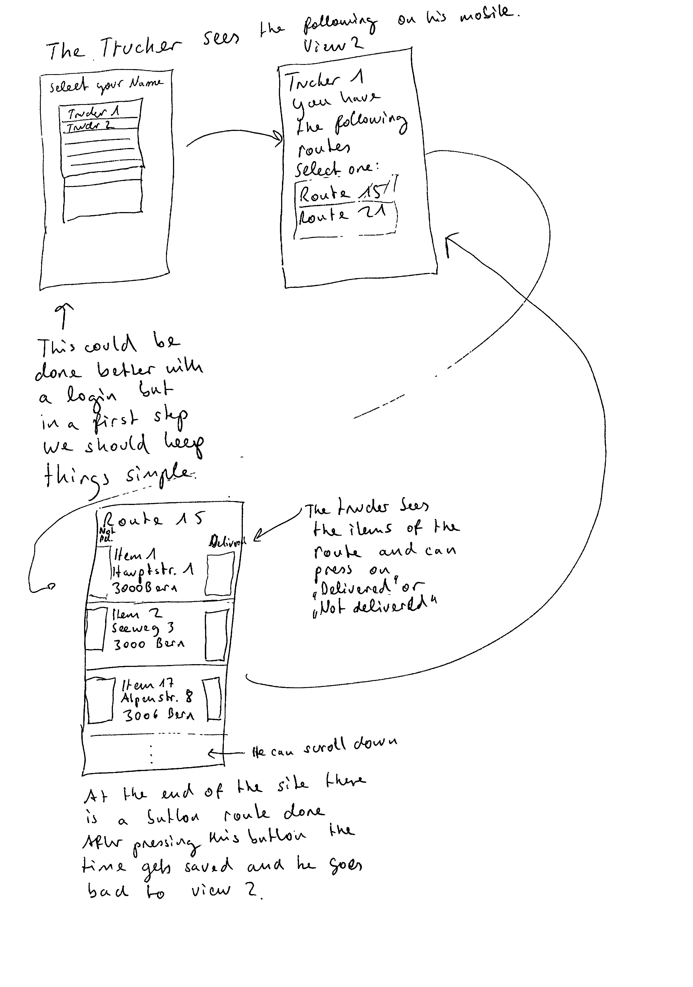

Non-functional requirements (external, performance, etc.)
Platform: What does it mean that it should run on mobile phones? Is it enough if it runs on a browser in a mobile phone?. Do we need a login?
Database: MySQL
Programming language: Java

